**Chapter 1**

**INTRODUCTION**

**Human computer interaction system:**  
 Human computer interaction system is one of the most manned systems in manned spacecrafts, which can be defined as the form in which astronauts use input and output devices to transfer information and energy with spacecrafts to complete a certain task.  
  
 The relationship between human-computer interaction system of manned spacecraft, astronauts and spacecraft is shown in Figure 1.

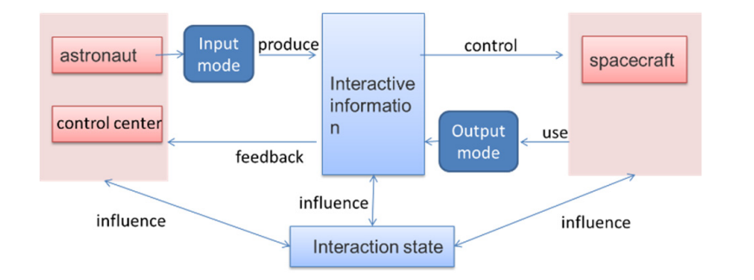

**Figure 1.1 Human computer interaction system of manned spaceflight**

**Development status:**  
 In order to meet the needs of 1-3 people's space shuttle and long-term stay mission, China's manned space flight has established a man-machine interaction system based on time division electronic display with multi-functional integrated layout and graphical interface as the leading role, which has been successfully applied to space shuttle, EVA activities, support manipulator operation, manned rendezvous and docking, long-term stay, on orbit load test and other missions, good results have been achieved.  
  
 At present, the main characteristics of the human-computer interaction system of China's manned spacecraft include:  
  
**1. Layered design concept:**  
 Closely combined with the characteristics of spacecraft mission, human-computer interaction system is divided into task-oriented interaction and application-oriented interaction. The task system realizes the basic functional requirements and task oriented requirements, and the design gives priority to reliability. The application system realizes the demand of application service and gives priority to innovation in design and implementation. On the premise of not affecting the security and task realization, it uses the commercial procurement method to design the advanced performance and man-machine friendly interactive system.  
  
**2. Distributed information system architecture:**

As a typical computer system, human-computer interaction system follows the distributed information system architecture design, as shown in Figure 2.

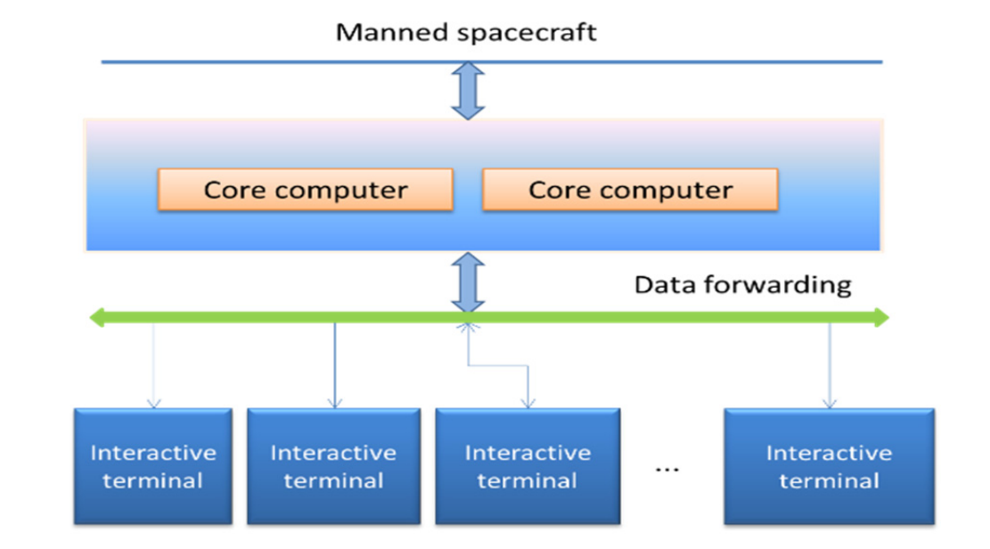

**Figure 1.2 Schematic diagram of instrument**

As the interface between the spacecraft and the interactive system, the core computer collects the spacecraft data that the astronauts need to know, and performs the calculation, fusion and processing. The "data forwarding" function module is used as the data exchange center between the interactive devices to complete the data exchange between the terminal and the core computer and between the terminals; As a human-computer interaction device, the function terminal completes the given interactive tasks.  
  
**3. Time division display mode:**  
 The core computer of the interactive system will process the interactive data of the spacecraft and send it to the multi-function display for presentation. According to the specific mission and flight phase, the multi-function display is divided into several typical working states. Each working state only displays the information needed by the astronauts in this phase, and also displays in real time.  
  
**4. Multimedia technology is the auxiliary:**

Integrating the original interactive data, spacecraft and mission status, video and audio information, astronauts can directly operate the interface window, menu, icon and other functional controls on the interactive equipment by using the buttons and touch modes provided by the interface, so as to realize the information interaction function of text, graphics, image and sound.

**Chapter 2**

**REQUIREMENTS OF HUMAN COMPUTER INTERACTION**

**A. Manned deep space exploration mission:**

The development plan of deep space exploration is usually formulated according to the three-step strategy of "exploration, landing and stationing ". "Exploration" and "landing" belong to short-term exploration tasks. After the rendezvous and docking process, the astronauts enter the planetary surface to carry out a certain range of lunar geological environment exploration, resource collection and relatively simple scientific experiments with the help of planetary surface mobile equipment. With the help of the sustainable development of the exploration base, it has the ability to detect the terrain and resources of the whole planet, carry out systematic and continuous scientific experiments, realize the development and utilization of in-situ resources of the planet, realize the supply of consumables and energy, and have the ability of infrastructure construction and maintenance of the planet base.  
  
 "Landing" in manned deep space exploration mission can be divided into landing mission, planetary surface mission and return mission. Typical missions are as follows:

* Launch phase: the launch vehicle launches several times to send the lunar mission module into low earth orbit and complete the assembly of the mission module.
* In the Earth Moon flight phase, the lunar mission module accelerates into the lunar orbit, and enters the lunar orbit after orbit correction and deceleration.
* Lunar module landing on the lunar surface: the lunar module gradually decelerates from the orbit around the moon and lands on the lunar surface.
* Lunar return phase: the crew takes the lunar return module to return to the lunar orbit from the moon and dock with the resident spacecraft to complete crew transfer.
* Moon to earth transfer phase: abandon the lunar surface return module, and the manned spacecraft enters the moon to earth transfer orbit from the lunar orbit.
* Reentry and return phase: abandon the propulsion module of manned spacecraft, and the reentry module will re-enter the earth's atmosphere for landing.

The typical manned activities in manned deep space exploration missions include:

* Precise landing and large-scale man-machine joint exploration. Around a certain central area, large-scale mining and construction activities are carried out in a certain range.
* Star catalog base construction and operation management. Catalog base is the cornerstone of long-term scientific exploration and resource development and utilization, and the premise of long-term scientific research work for astronauts.
* In situ resource exploitation and utilization. By surveying, acquiring and utilizing the natural resources of extraterrestrial objects, people can live, produce, experiment and exploit the resources for a long time.

**B. Human computer interaction system requirements**

According to the mission planning of manned deep space exploration, the requirements of human-computer interaction system can be divided into three levels.

* The first level: basic functional requirements. In order to meet the needs of ensuring the safety of spacecraft and the life safety of astronauts in orbit under any conditions. It mainly includes the monitoring and perception of spacecraft and human's own state, over limit alarm, fault handling, manual operation (including automatic control/manual rendezvous and docking, manual landing / return), space and sky video/audio communication, etc.
* The second level: task requirement oriented. It can ensure the stable operation of spacecraft and support the astronauts to complete the short-term mission of deep space exploration. It includes the monitoring and sensing of spacecraft external environment, teleoperation rendezvous and docking, intelligent teleoperation robot or manipulator inside and outside the cabin, out of the cabin, on orbit maintenance, etc.
* The third level: application service requirements. It can satisfy the functions involved in astronauts' long-term stay on the planetary surface, including autonomous fault location and repair, multi-agent autonomous collaborative sensing and fusion, human-computer joint sampling, human-computer fusion detection, intelligent planning and implementation of the whole construction process. autonomous planning and decision-making, etc.

The requirement analysis of human-computer interaction system based on deep space exploration mission is shown in Figure 3.

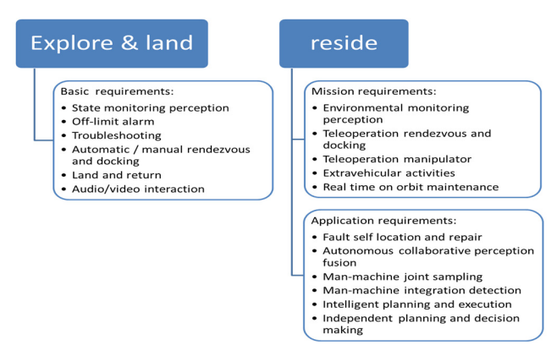

**Figure 2.1 Human computer interaction system requirements**

**Chapter 3**

**DEVELOPMENT TREND**

* From graphical interface to Spontaneous interaction The human-computer interaction system based on deep space exploration should start from the graphic interaction technology, and establish astronauts as social people. On the basis of the existing life experience, the system uses the natural attributes of voice, handwriting, posture, eye tracking, expression, bone tracking, etc. to achieve the effect of somatosensory interaction. For further development, it is necessary to achieve intelligent spontaneous interaction with the support of pervasive computing technology, that is, computing, interaction, situational awareness and other modules are embedded and hidden in the spacecraft. The modules cooperate with each other and can actively provide three-dimensional and continuous interaction channels for the astronauts, understand and predict the interaction needs of the astronauts in the process of completing the mission, so as to realize unconstrained.
* From single channel and mode to Multichannel The human-computer interaction system based on deep space exploration uses more multimedia technology. The input means are natural, multimodal, and the output means are light media and de instrumental. The system collects the information generated by spacecraft and astronauts, and forms a virtual user expression module after understanding, processing and management, With the support of big data, Internet of things and cloud computing technology, the "interactive material" database is formed to realize the information interaction and expansion of different networks, platforms and interactive devices between the interior of manned spacecraft and the ground, support the cross network multi-agent collaborative interaction, build a task-based and joint ground system architecture, and reduce the complexity of astronaut in orbit information processing, Improve the interaction effect.
* From man machine cooperation to man machine intelligence fuse  
  In view of the missions with high-risk coefficient and harsh environmental conditions, or the detection and test missions with high precision, large amount of data calculation and repeated experiments that conform to the characteristics of robots. Automatic perception of the needs of astronauts, through intelligent fusion, has given the correct judgment, and push to the astronauts, to achieve "situational awareness". It introduces human-computer intelligent integration, creates deep learning system, constructs and constantly updates and upgrades mental model through contact and learning, makes accurate judgment on astronauts' work and life in orbit, independently formulates, adjusts and executes mission plan. and timely gives reasonable and correct solutions.

**Chapter 4**

**DESIGN OF HUMAN COMPUTER INTERACTION SYSTEM**

**A. Conceptual model**  
 The human-computer interaction system of manned spacecraft based on deep space exploration is divided into two parts: the task interaction module based on "exploration" and "landing" missions to meet the basic functional requirements; Based on the "resident" mission, it is an application interaction module to meet the requirements of mission oriented and application service. See Figure 4 for details.

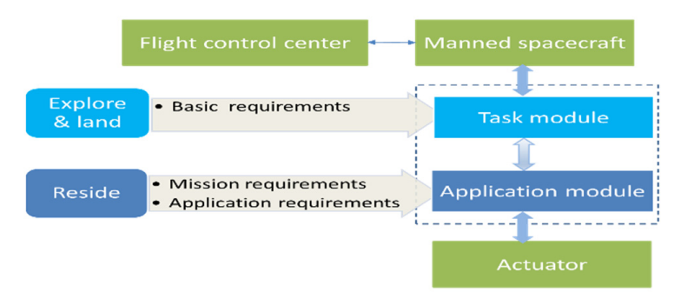

**Figure 4.1 Human computer interaction system of manned spacecraft**

The conceptual model of human-computer interaction system for manned spacecraft based on deep space exploration mission is shown in Figure 5.

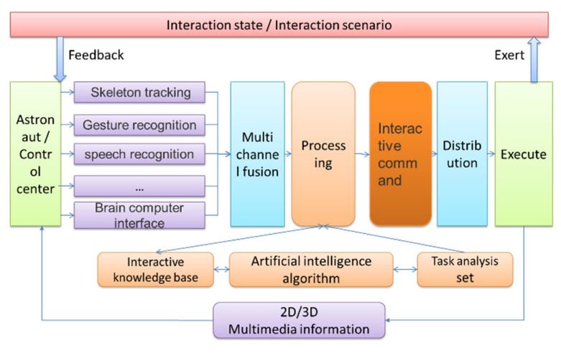

**Figure 4.2 Conceptual model of human computer interaction system**

In the task interaction module and application interaction module, "human" is the astronaut or the ground personnel who perform the teleoperation through the link between the earth and the sky, "machine" is the manned spacecraft or the executive mechanism which performs the operation and detection instead of human. The interaction between the two involves four aspects: input mode, output mode, interactive information and interactive state. The input and input between human and computer use natural multimodal interaction technology, and the processing of interactive information uses artificial intelligence technology for intelligent fusion of interactive information.  
  
**B. Architecture design**  
 The human-computer interaction system architecture of manned spacecraft based on deep space exploration mission is divided into four layers, as shown in Figure 6.

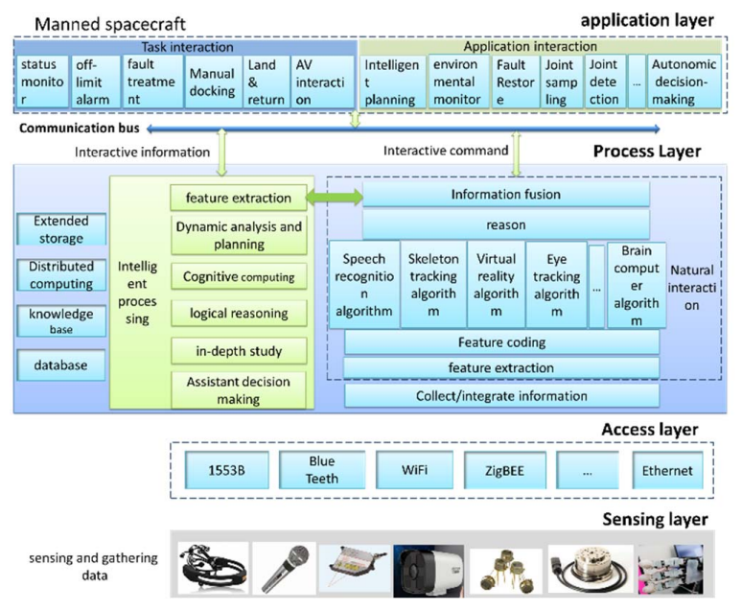

**Figure 4.3 Architecture of human computer interaction system**

The perception layer is located at the bottom of the system architecture, and its function is "perception", that is to identify and obtain environmental information through various sensors and collection devices. Sensors and acquisition devices include human natural attribute acquisition devices; It also includes environmental attribute acquisition devices, such as camera, thermal sensor, QR code tag and reader, position sensor, etc.

The access layer uses bus cable, optical fiber, coaxial cable, wireless access and other transmission media to realize the connection with the perception layer, and to allocate services and bandwidth, so as to ensure that the information collected by the interactive terminal can be connected to the processing module of the interactive system in real time and accurately.  
  
 The processing layer uses a variety of intelligent technologies to analyze and process the data and information perceived and transmitted, generate new interactive commands and interactive information, and realize the natural and intelligent process.  
  
 The application layer is the process of interactive information command and interactive information to play a role in the end. There are many forms of expression. The more important is to adjust the state of the object and its transformation mode, so that the object is always in a pre-designed state.  
  
**C. System composition**  
 The human-computer interaction system based on deep space exploration task follows the distributed information architecture. As the core equipment of the system, the interactive computer is connected with the manned spacecraft platform through communication interfaces, receives the interactive data and information collected by the interactive terminal and sensors, and processes them according to the data processing rules of the interactive terminal, After information intelligent fusion, it is sent to the spacecraft platform or actuator for display and presentation.  
  
 The composition of human-computer interaction system for manned spacecraft based on deep space exploration mission is shown in Figure 7.

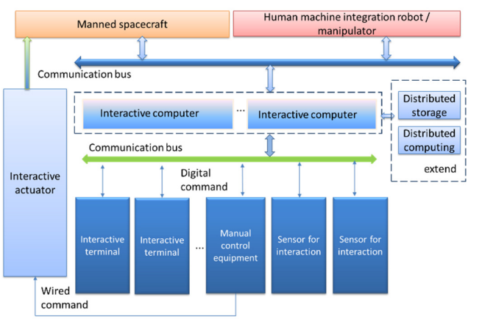

**Figure 4.4 Composition of human computer interaction system**

As the information interface between human-computer interaction system and manned spacecraft, interactive computer is the core equipment of data processing, operation and data storage for multimodal natural interaction and intelligent interaction, which completes the data exchange and intelligent processing between interactive systems. The interactive computer receives the data stream generated by the terminal through the "data forwarding" function module and sends the processed and integrated interactive commands to the multimodal naturalized interactive terminal through the "data forwarding" function module to complete the given interactive tasks.

**Chapter 5**

**DISCUSSION ON THE WAY OF REALIZATION**

**A. Engineering application of commercial products** In the future, the research and development of manned spacecraft is to purchase the products from stock through commercial channels and transplant them into the human computer interaction system of manned spacecraft, which can reduce a lot of modification and maintenance funds, greatly shorten the development cycle of the space system and reduce the development cost of the system.  
  
Practice of manned spacecraft, the following problems should be paid attention to:

* Identification Scope of application, avoiding system design risk.
* Clear selection factors and carry out adaptability analysis in advance.
* Identify platform application bottlenecks and comprehensively sort out development risks. Including power supply characteristics, information security, install the interface, heat consumption and heat dissipation conditions, electromagnetic compatibility.
* Plan thoroughly and test thoroughly to standardize the flight status of products.

**B. Integrated artificial intelligence**  
 Fully promote the combination of technologies such as Internet of animals, large-scale parallel computing, big data and deep learning algorithm with aerospace human-computer interaction, realize the perfect integration of intelligent collection, remote support and intelligent decision-making of human-computer interaction system, and change the development mode of human-computer interaction system from providing products to providing all-round interactive solutions. Based on big data and artificial intelligence technology, comprehensive human-computer interaction service can realize independent planning and intelligent decision-making.

**Chapter 6**

**Conclusion**

The human-computer interaction system of manned spacecraft based on deep space exploration is an indispensable part of the future spacecraft. It can ensure the safety of astronauts, assist astronauts to complete planetary surface operation tasks more efficiently, and carry out planetary surface operation for a longer time and a wider area. It is the highlight of China's manned deep space exploration in the future. In the follow-up research, we need to focus on the key technologies of humanoid robot, teleoperation control, human-computer cooperative operation and so on.

**References**

[1] Zhou Qianxiang, Wei zhehao. Research progress of human computer interaction technology for manned spacecraft [J]. Chinese Journal of aerospace medicine, 2005, Vol.16, No.4  
  
[2] Zhang Zhixian, Guo Linli, Qi Faren. Conceptual Study on Crew-Robot Coordinated Exploration on Lunar Surface[J]. Manned Spaceflight, Vol 20 No.5 Sep.2014  
  
[3] Sanders G B. Larson W E. Progress made in lunar in situ resource utilization under NASA's exploration technology and development program[J]. Journal of Aerospace Engineering, 2012, 26 (1): 5-17.  
  
[4] Zhang Chongfeng, Han Liangliang. Preliminary Study on Lunar Robot for Manned Lunar Exploration[J]. Manned Spaceflight, Vol 25 No.5 Oct.2019  
  
[5] Liang zhongchao Wang yongfu. Liu zhen, et al. Analysis on handling deviation caused by different gravities for lunar roving vehicle[J]. Journal of Harbin Institute of Technology, 2017(1):114-119  
  
[6] LOing B H. The moon as a platform for astronomy and space science[J]. Advanced Space Research, 2016, 4(02): 17-23